Saim Ali  
  
**Hanoi**

Learn time complexity

Relearn how to do algorithm

**Read/write disks**Learn how todofor both column and row major

Column – left to right

Row – up to down

**Huffman**learn algorithm  
learn how to manually do the algorithm on a string

ALWAYSdadadawd ADD THE LOWEST NODES TOGETHER?  
Huffman Encoding Guide:

1. Set up characters with the lowest frequency to highest.

2. Select 2 lowest frequencies, connect them, then add them together.

3. Label 0 for smaller number, 1 for big number (If the 2 values are the same, label 0 for left value, 1 for right).

4. Go back to step 2 until only 1 value remains.

5. Starting from the end of the tree, trace it to the letter to determine its code.

6. Once all characters' codes are determined, count the amount of digits for each code to get its length.

7. Once all lengths are determined, compute for the final result.

FORMULA: FINAL RESULT = Σ(Length x Frequency)

**Quicksort**Best case will always be when pivot is the median  
Worst case can be if the array is already sorted

Learn time complexity

Best – O(nLogn)

Worst – O(n^2)  
  
**PSUEDO**  
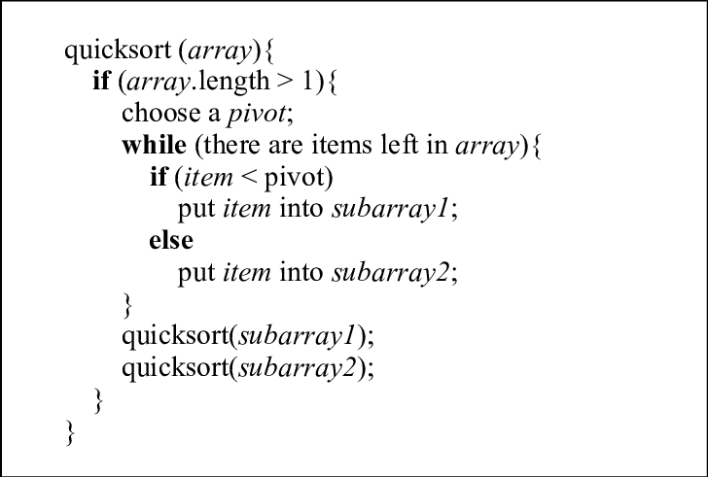  
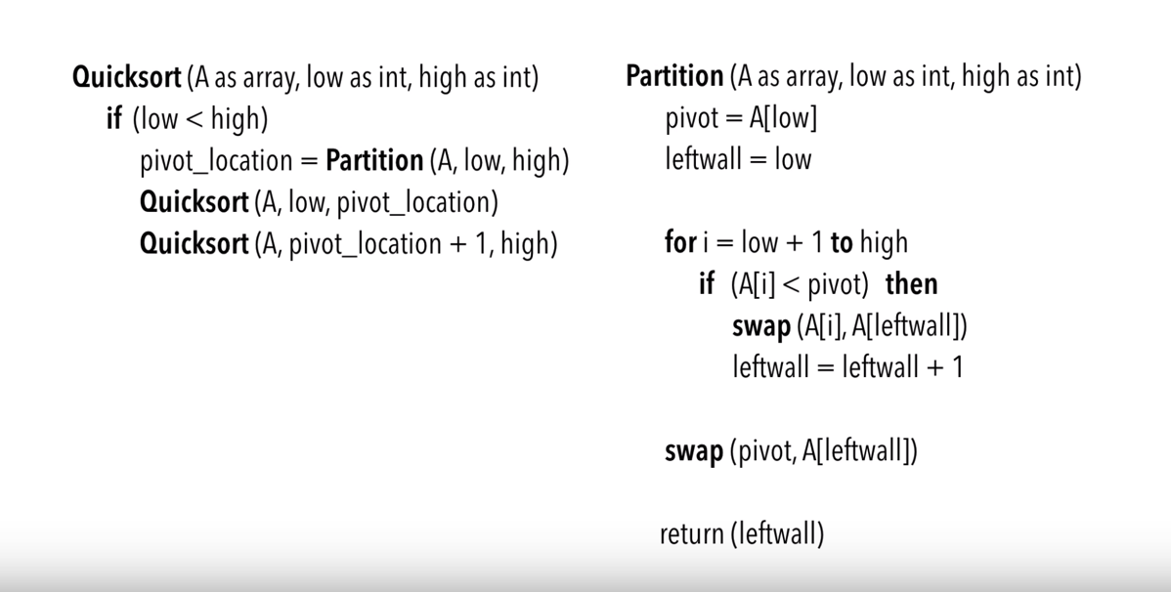

**  
**IF ASKS FOR AVG DO: ALL VALUES / NUMBER OF VALUES (I guess)  
EX : M[1,3] = 54 + 324/2**

**heapsort**No idea